**Assignment 3 – Business Add in (BADI)-Single Use**

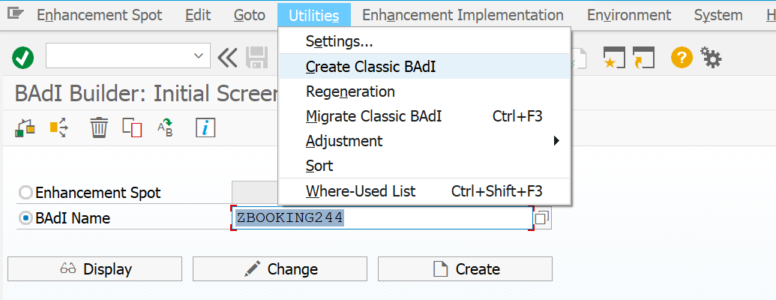

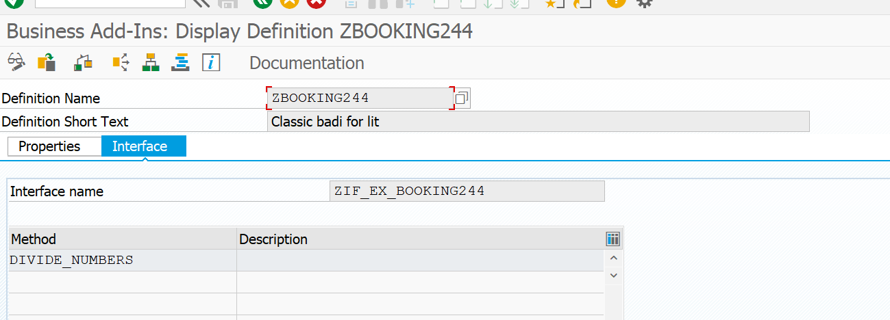

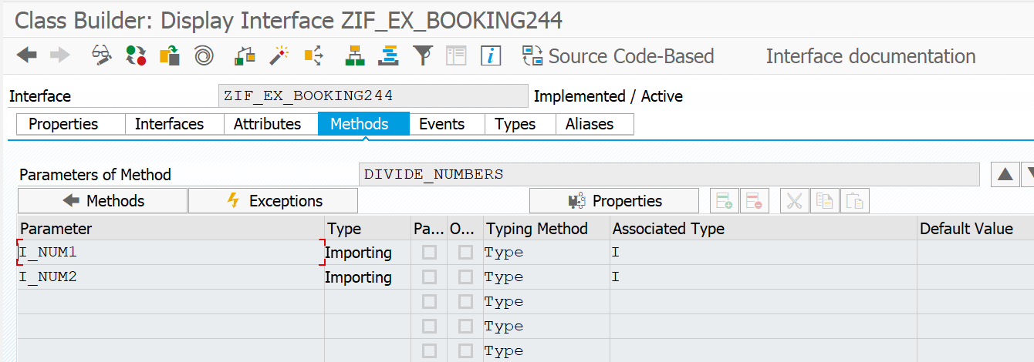

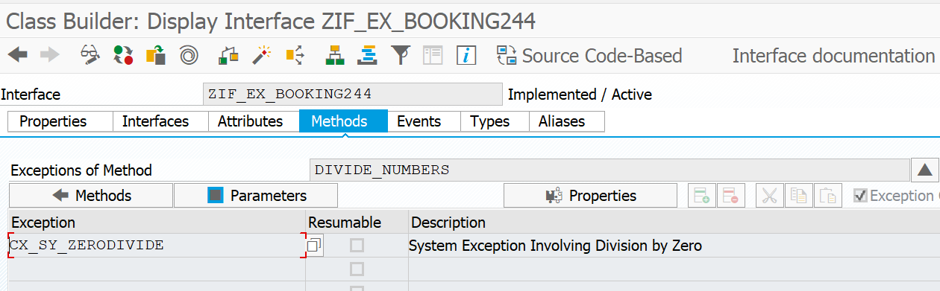

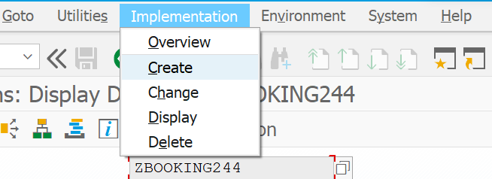

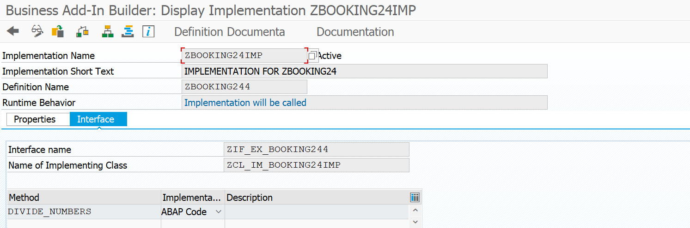

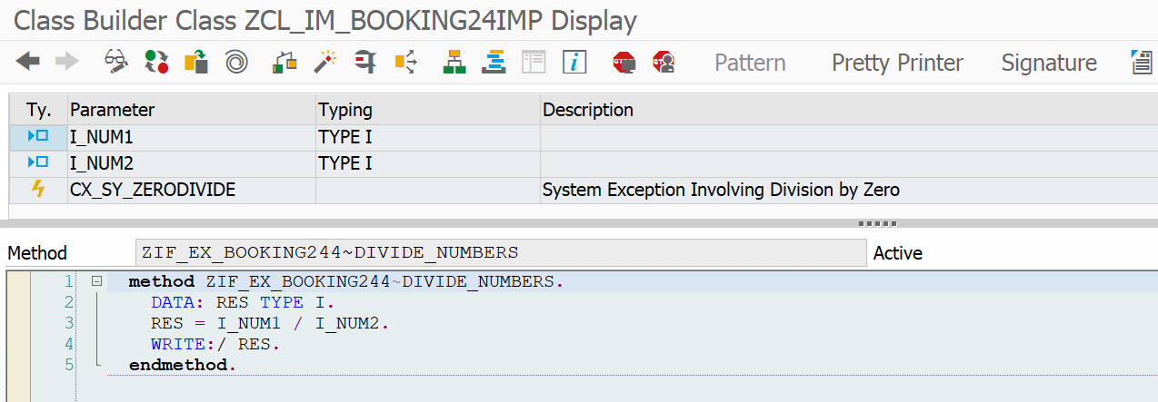

PROGRAM:

REPORT Z24BADI.  
  
START-OF-SELECTION.  
  
CLASS CL_EXITHANDLER DEFINITION LOAD.  
  
DATA: RES TYPE I.  
  
DATA OBJ TYPE REF TO ZIF_EX_BOOKING244.  
  
PARAMETERS : I_N1 TYPE I,  
             I_N2 TYPE I.  
  
CALL METHOD cl_exithandler=>get_instance  
  EXPORTING  
    exit_name                     = 'ZBOOKING244'  
*    null_instance_accepted        = SEEX_FALSE  
*  IMPORTING  
*    act_imp_existing              =  
  CHANGING  
    instance                      = OBJ  
  EXCEPTIONS  
    no_reference                  = 1  
    no_interface_reference        = 2  
    no_exit_interface             = 3  
    class_not_implement_interface = 4  
    single_exit_multiply_active   = 5  
    cast_error                    = 6  
    exit_not_existing             = 7  
    data_incons_in_exit_managem   = 8  
*    others                        = 9  
        .  
*IF sy-subrc <> 0.  
*  MESSAGE 'EXIT NOT FOUND' TYPE 'E'.  
*ENDIF.  
  
TRY.  
CALL METHOD obj->divide_numbers  
  EXPORTING  
    i_num1 = I_N1  
    i_num2 = I_N2  
    .  
 CATCH cx_sy_zerodivide .  
ENDTRY.

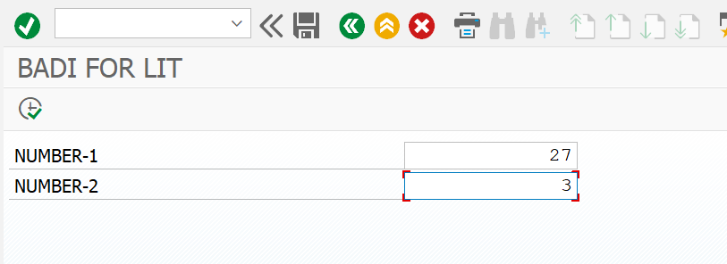

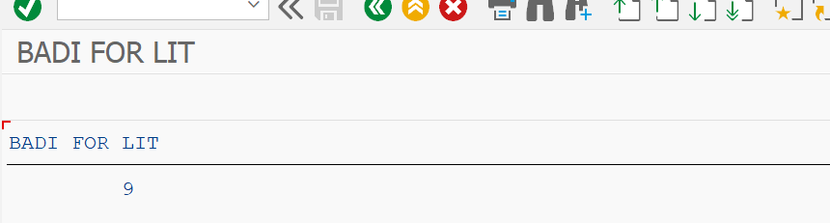

**Assignment 4 – Business Add in (BADI)-Multiple Use**

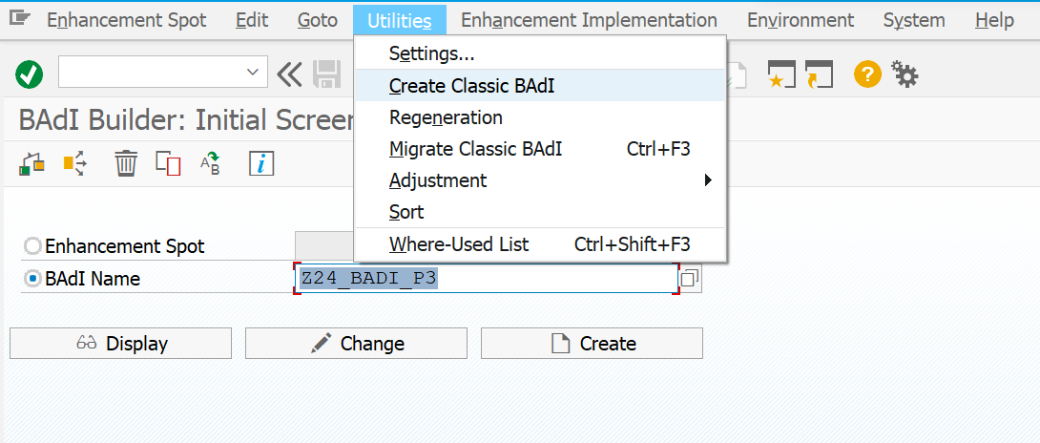

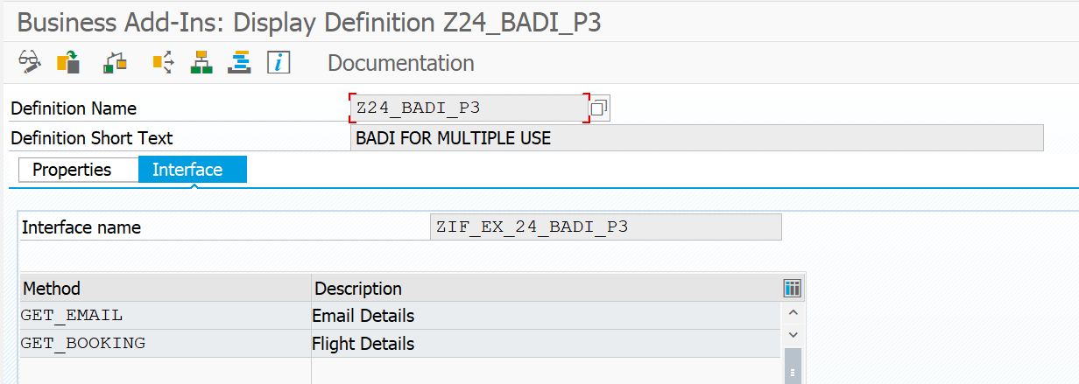

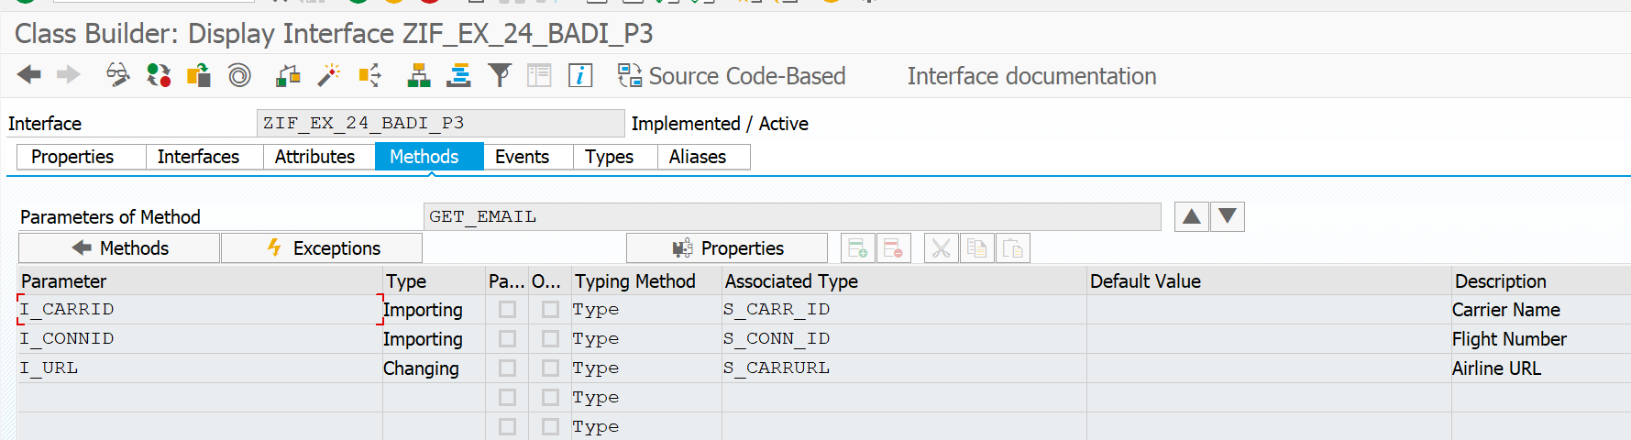

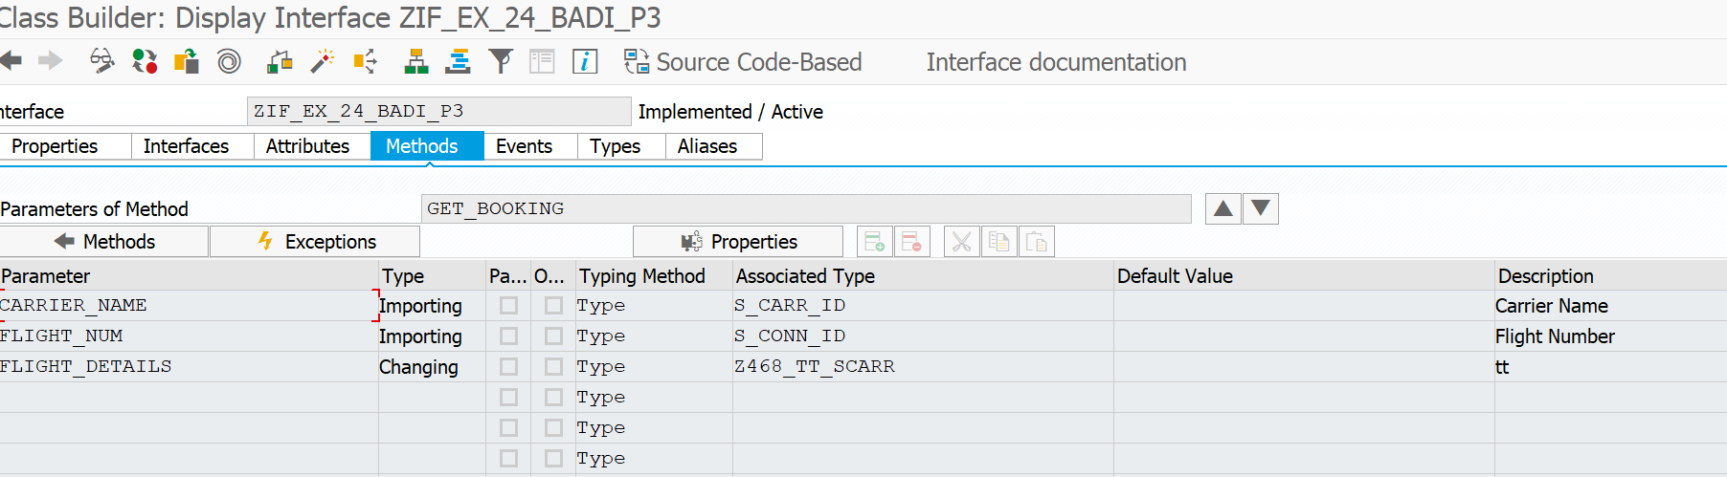

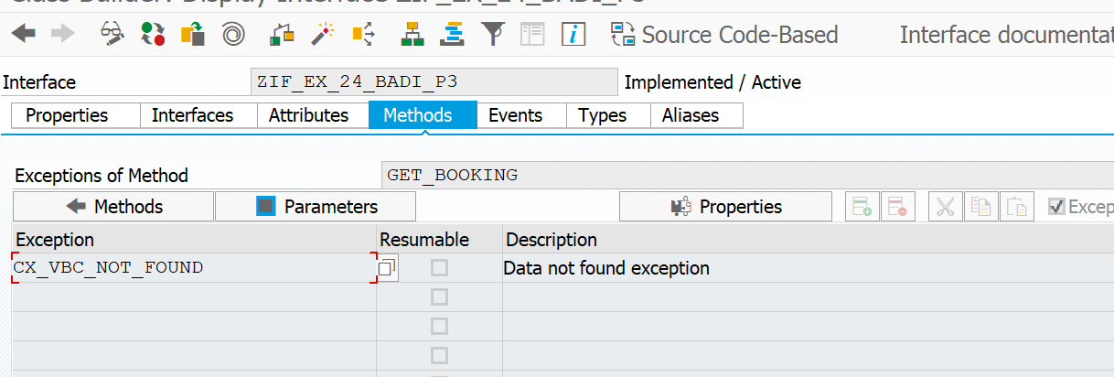

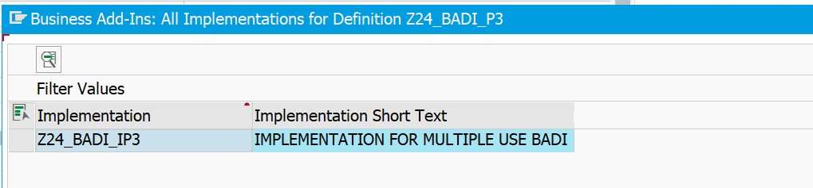

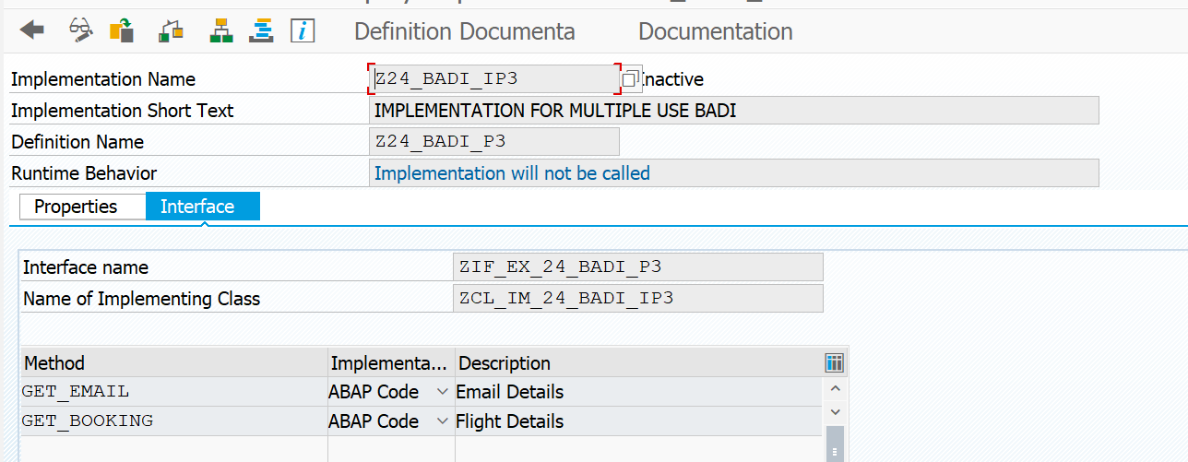

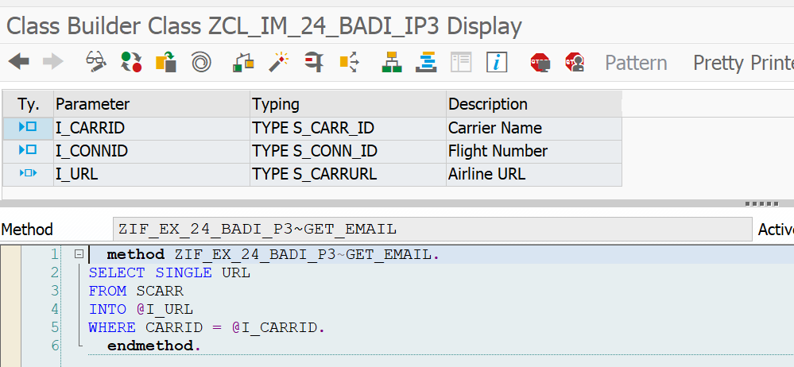

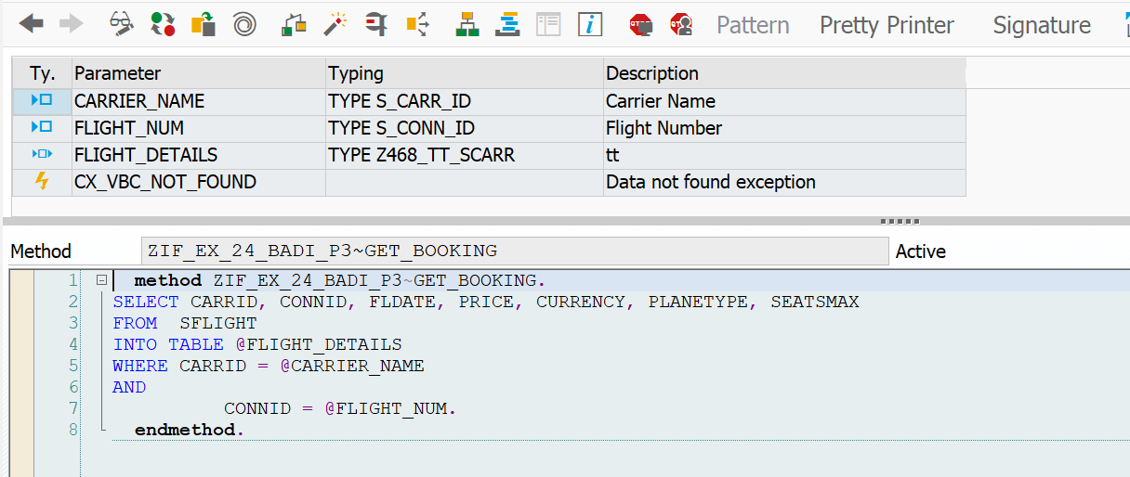

**PROGRAM**

REPORT Z24_DAY10_P4.  
 DATA: VAR TYPE REF TO ZIF_EX_24_BADI_P3.  
   
PARAMETERS: p_carr TYPE S_CARR_ID,  
 P_flight TYPE S_CONN_ID.  
   
  
DATA : it_flight TYPE Z468_TT_SCARR, *" declaring internal table of sflight*  
 *gs_sflight* TYPE line of Z468_TT_SCARR,  
 url type s_carrurl.  
 CL_EXITHANDLER=>GET_INSTANCE(  
 EXPORTING  
 EXIT_NAME = 'Z24_BADI_P3' *" Business Add-In Definition*  
 *\* NULL_INSTANCE_ACCEPTED = " Is Null Instance OK if There Is no Active Implementation?*  
 *\* IMPORTING*  
 *\* ACT_IMP_EXISTING = " Returns an Active Implementation*  
CHANGING  
 INSTANCE = var *" Instance*  
EXCEPTIONS  
 NO_REFERENCE = 1  
 NO_INTERFACE_REFERENCE = 2  
 NO_EXIT_INTERFACE = 3  
 CLASS_NOT_IMPLEMENT_INTERFACE = 4  
 SINGLE_EXIT_MULTIPLY_ACTIVE = 5  
 CAST_ERROR = 6  
 EXIT_NOT_EXISTING = 7  
 DATA_INCONS_IN_EXIT_MANAGEM = 8  
 OTHERS = 9  
 ).  
 IF SY-SUBRC <> 0.  
 *\* MESSAGE ID SY-MSGID TYPE SY-MSGTY NUMBER SY-MSGNO*  
 *\* WITH SY-MSGV1 SY-MSGV2 SY-MSGV3 SY-MSGV4.*  
ENDIF.  
   
*TRY.  
 CALL METHOD var->get_booking  
 EXPORTING  
 carrier_name = P_CARR  
 flight_num = P_FLIGHT  
 CHANGING  
 flight_details = IT_FLIGHT  
 .  
 *\* CATCH cx_vbc_not_found .*  
 *\*ENDTRY.*  
  
  
*CALL* METHOD var->get_email  
 EXPORTING  
 i_carrid = P_CARR  
 i_connid = P_FLIGHT  
 CHANGING  
 i_url = URL  
 .  
   
WRITE: / 'Airline URL is' COLOR COL_POSITIVE, url.  
 WRITE: 40 'Flight Details' COLOR COL_POSITIVE.  
 WRITE: / 'CARRID',  
 10 'CONNID',  
 20 'FLDATE',  
 31 ' PRICE',  
 52 'CURRENCY',  
 63 'PLANETYPE',  
 75 'SEATSMAX'.  
 ULINE.  
 LOOP AT it_flight INTO gs_sflight.  
 WRITE : / gs_sflight-carrid LEFT-JUSTIFIED,  
 10 gs_sflight-connid,  
 20 gs_sflight-fldate,  
 31 gs_sflight-price,  
 52 gs_sflight-currency,  
 63 gs_sflight-planetype,  
 75 gs_sflight-seatsmax.  
 ENDLOOP.

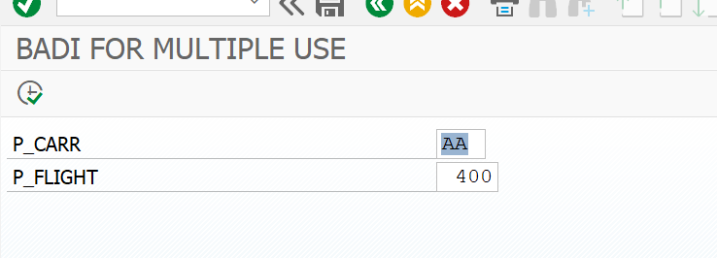

**OUTPUT:**

